GROUPE DE LA BANQUE AFRICAiNE

DE DEVELOPPEMENT

AFRiCAN DEVELOPMENT BANK GROUP

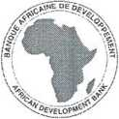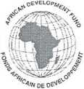

AGRICULTURE & AGRO-INDUSTRY DEPARTMENT (AHAI)

DEPARTEMENT DE L’AGRICULTURE & DE L’AGRO-INDUSTRIE (AHAI)

**Ref:** AHAI/LET/PA/2019/09/04

Date: 0 5 SEP. 2019

**Natasha Hayward**

Program Head, GAFSP

GAFSP Coordination Unit

The World Bank

1818 H Street, NW

**Washington D.C 20433, USA**

[gafsp-info@gafspfund.org](mailto:gafsp-info@gafspfund.org)

Dear Ms. Hayward,

**Letter of Support from the African Development Bank as the Selected Supervising Entity for the Central African Republic GAFSP Proposal**

With reference to the attached letter Ref. No: 171/MADR/DIRCAB.2019 dated 9 April 2019, the Government of the Central African Republic selected the African Development Bank as the preferred Supervising Entity to respond to the GAFSP 5th Call for Proposals. The Bank responded favorably and supported the Central African Republic authorities and the Food and Agriculture Organization during the preparation of the proposal titled: **Support Project for Reinforcement of Resilience and Food and Nutrition Security in Kemo and Ouaka Districts (PARSANKO).**

The proposal is part of a broader program of transformation of the Central African Republic’s agriculture sector through the development of commodity value chains. The activities contained therein, subject to GAFSP funding in the amount of USD 18 million, seek to sustainably improve resilience, food and nutrition security and livelihoods of rural populations affected by social instability. It also complements on-going interventions by development partners in support of smallholder farmers in the target areas where the incidence of poverty is very high.

The proposal being submitted to GAFSP is consistent with the Central African Republic’s National Recovery and Peace Building Plan (RCPCA) for the period 2017-2021; the National Agricultural Investment Program for Food and Nutrition Security (PNIASAN); and the Feed Africa Strategy of the Bank. The African Development Bank and FAO discussed the proposal extensively with the authorities and other stakeholders in a consultative workshop.

The Bank is ready to serve as Supervising Entity and assist the Government of the Central African Republic in all aspects related to the formulation, approval, implementation and supervision of the project resulting from this proposal. The Bank has a broad range of experience in agriculture related initiatives within the country and elsewhere in Africa. The Bank is currently the Supervising Entity of several projects funded by GAFSP resources. Specialists in the Bank’s Country Office in Bangui will reinforce its supervisory role in the project rollout.

Yours sincerely,

**Martin FREGENE**

**Director**

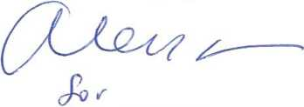

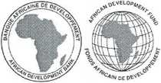

**AHAI - DIRECTOR**

Cc:

Mrs. Jennifer BLANKE, Vice-President, AHVP

Mr. Ken JOHM, Bank GAFSP Coordinator

Mr. Patrick AGBOMA, Lead, Scale Technologies & Market Access